Forecasting and Simulation of Video Game Sales and EasyB&B.com

***Part A***

1. Analysis of Yearly Global Sales by Genre (Video Games):

The analysis of yearly global sales data for video games across the Action, Adventure, and Shooter genres from 1997 to 2011 revealed varying trends among the genres. The graph depicting the yearly global sales per genre shows that the Shooter genre experienced a significant increase in popularity, particularly in the later years, suggesting that it is not heavily influenced by seasonal fluctuations. The steep upward trend of the Shooter genre indicates a rapid growth in sales over time. In contrast, the Action and Adventure genres exhibited more stable sales trends, with relatively smaller fluctuations and a more gradual increase over the years.

Several factors, such as technological advancements, market expansion, and changing consumer preferences, have likely contributed to these trends. The growth of the Shooter genre may be attributed to the rise of online gaming and multiplayer features, which have become increasingly popular in recent years.

2. Forecasting Sales for the Action Genre:

Three forecasting methods were applied to the Action genre sales data: Naïve method, Three-period moving average, and Exponential smoothing (α = 0.4). The results showed that Exponential Smoothing provided the most balanced forecasting, effectively adapting to recent sales trends without overfitting historical data. The Naïve method and Three-period moving average were less responsive to changes in the trend.

The Naïve Forecast yielded a value of 40.32, while the Moving Average Forecast provided a series of values with the last forecast being approximately 46.62. The Exponential Smoothing Forecast resulted in a value of 45.11646. These results indicate that the Exponential Smoothing method provides a more reasonable forecast, considering the recent trends in the data.

3. Recommended Forecasting Model:

Exponential Smoothing is recommended for forecasting future sales of Action genre video games, as it offers a good balance between simplicity and the ability to adapt to recent sales data trends. The forecast of 45.12 appears reasonable given the recent trends in the data, reflecting a balance between historical sales patterns and adjustments for recent changes.

4. Comparison of Forecasting Models:

Holt-Winters exponential smoothing, an advanced version of exponential smoothing those accounts for both trend and seasonality, was compared to simple exponential smoothing. The results showed that Holt-Winters exponential smoothing outperformed simple exponential smoothing by capturing both the overall trend and any seasonal patterns in the Action genre sales data, resulting in more accurate long-term forecasts.

The Holt-Winters exponential smoothing model provided point forecasts of 45.11646 for the next two periods, with corresponding prediction intervals. The lower 80% and 95% prediction intervals for the first forecasted period were 30.58474 and 22.89211, respectively, while the upper 80% and 95% prediction intervals were 59.64818 and 67.34081. For the second forecasted period, the lower 80% and 95% prediction intervals were 29.46532 and 21.18011, and the upper 80% and 95% prediction intervals were 60.76760 and 69.05281. These prediction intervals provide a range of plausible values for the forecasted sales, considering the uncertainty associated with the forecast.

The RMSE (Root Mean Squared Error) of the forecast was calculated to be 5.64604342085368, indicating the average deviation of the forecasted values from the actual values. A lower RMSE value suggests a better fit of the model to the data and more accurate predictions.

5. Relationship between Review Scores and Global Sales:

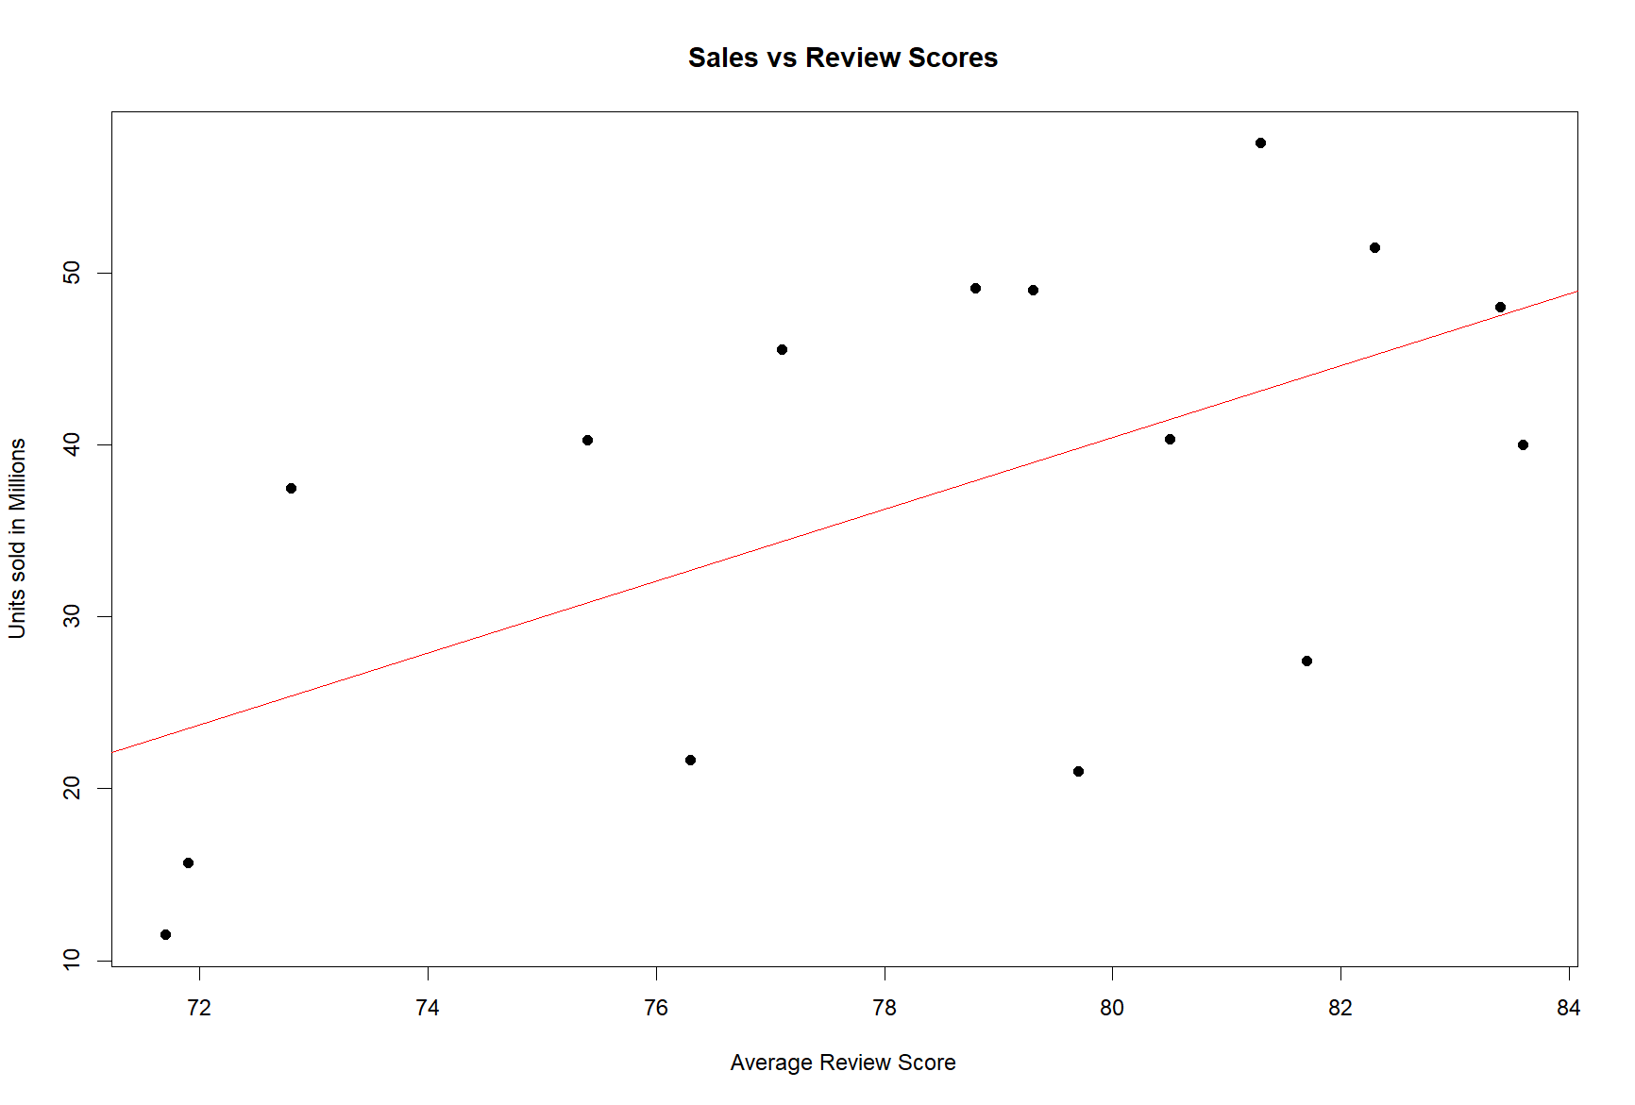

The analysis of the relationship between global sales and average review scores for the Action genre using the method of least squares revealed a positive correlation. The scatter plot of the data points and the fitted regression line visually demonstrates this positive relationship, with higher review scores generally associated with higher global sales figures.

The linear regression model showed that an increase in the average review score was associated with an increase in global sales. The model coefficients indicate that for every unit increase in the average review score, the global sales are expected to increase by 2.0917 million units, assuming all other variables remain constant. The intercept term suggests that if the average review score were zero, the global sales would be negative, which is not meaningful in this context and indicates the need for caution when interpreting the results outside the observed range of review scores.

However, the moderate strength of the relationship, as indicated by the R-squared value of 0.3502, suggests that other factors also influence sales performance. The R-squared value indicates that approximately 35% of the variation in global sales can be explained by the variation in average review scores, while the remaining 65% is attributed to other factors not included in the model.

Using the fitted linear regression model, the predicted global sales for a hypothetical future review score of 85 was calculated to be 50.91347 million units. This prediction suggests that if a new Action genre video game were to receive an average review score of 85, its global sales would be expected to be around 50.91347 million units, based on the historical relationship between review scores and sales in this dataset. However, it is important to note that this prediction is subject to uncertainty and should be interpreted with caution, as it assumes that the relationship between review scores and sales remains stable over time and that no other significant factors influence the sales performance.

***Part B***

Simulation of Easy B&B

The simulation of operations under two scenarios, one with a single customer service representative and another with two representatives, yielded insightful results. In the single representative scenario, the average waiting time was found to be 9.470278 minutes, while in the two-representative scenario, the average waiting time was significantly lower at 0.8893869 minutes.

Furthermore, the percentage of calls handled within the target time of 3 minutes was 39% for the single representative scenario and 87% for the two-representative scenario. These results demonstrate that adding a second representative can significantly reduce average waiting times and improve the overall customer experience.

The simulation also provided detailed results for each scenario. In the single representative scenario, the average total time in the system was 16.96028 minutes. This means that, on average, a customer would spend a total of 16.96028 minutes in the call centre, including both waiting time and service time. In the two-representative scenario, the average total time in the system was reduced to 8.379387 minutes, indicating a substantial improvement in the overall efficiency of the EasyB&B business.

These results highlight the importance of adequate staffing levels in operations. By adding a second representative, the business can significantly reduce waiting times, increase the percentage of calls handled within the target time, and improve the overall customer experience. The reduction in average total time in the system also suggests that the organisation can handle more calls within a given timeframe, potentially leading to increased productivity and cost savings.

Analysis of Statistical Metrics and Recommendations:

The key performance indicators, such as average waiting time and percentage of calls within the target time, clearly show that having two representatives leads to better performance. The average waiting time is reduced from 9.470278 minutes in the single representative scenario to 0.8893869 minutes in the two-representative scenario, a significant improvement that can greatly impact customer satisfaction. Additionally, the percentage of calls handled within the 3-minute target time increases from 39% to 87% when a second representative is added, ensuring that a larger proportion of customers receive prompt service.

To further optimize the business dynamic staffing, where the number of representatives is adjusted based on real-time data, is recommended. By analysing call volume patterns and other relevant metrics, the call centre can make data-driven decisions to allocate resources effectively. This approach can help strike a balance between providing excellent customer service and maintaining cost efficiency.

Furthermore, technological upgrades to implement more efficient call routing systems can help improve the overall efficiency of the organisation. Advanced call routing algorithms can match customers with the most suitable representatives based on factors such as skill level, availability, and customer profile. This can lead to faster resolution times, increased first-call resolution rates, and improved customer satisfaction.

Conclusion:

The analyses and simulations conducted in this report highlight the importance of optimizing staffing levels and utilizing efficient forecasting models for improving the operational efficiency of EasyB&B business. The results demonstrate that increasing the number of customer service representatives can significantly reduce waiting times, increase the percentage of calls handled within the target time, and enhance the overall customer experience.

Furthermore, the application of advanced forecasting techniques, such as Holt-Winters exponential smoothing, can provide more accurate predictions of future sales trends in the video game industry. The positive relationship between review scores and global sales suggests that incorporating review data into forecasting models may improve their accuracy, although other factors also play a significant role in determining sales performance.

By implementing the recommended changes, such as dynamic staffing and technological upgrades, EasyB&B can expect to see enhanced customer satisfaction and operational cost savings. Regularly monitoring key performance indicators and adapting to changing customer needs will be crucial for maintaining a high level of service quality and staying competitive in the market.

References

- Gardner, E. S. (1985). Exponential smoothing: The state of the art. *Journal of Forecasting, 4*(1), 1-28.

[**https://onlinelibrary.wiley.com/doi/abs/10.1002/for.3980040103**](https://onlinelibrary.wiley.com/doi/abs/10.1002/for.3980040103)